Name :SK.Kashifa

Registration no :192121135

Agriculture loan management

Class diagram:

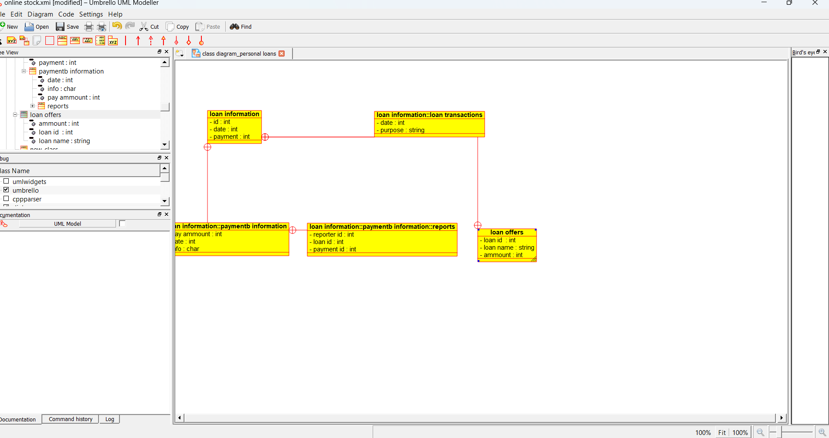

Use case diagram :

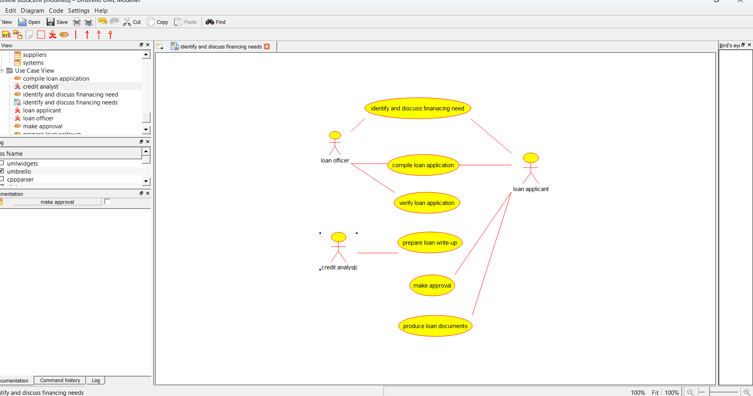

Deployment diagram :

